## 实验 Classes:A DeeperLook,Part 2

## 学号: 09017423 姓名：杨彬

### 实验目的

OBJECTIVES :

In this chapter you willl learn:

􀁺 To specify const (constant) objects and constmember functions.

􀁺 To create objects composed of other objects.

􀁺 To use friend functions and friend classes.

􀁺 To use the this pointer.

􀁺 To create and destroy objects dynamically with operatorsnew and delete, respectively.

􀁺 To use static data members and member functions.

􀁺 The concept of a container class.

􀁺 The notion of iterator classes that walk through theelements of container classes.

􀁺 To use proxy classes to hide implementation details froma class’s clients

### 实验内容

**EX1**:Simple Calculator

Write a SimpleCalculator class that has public methods for adding, subtracting, multiplying and dividing twodoubles. A sample call is as follows:

double answer = sc.add( a, b );

Object sc is of type SimpleCalculator. Member function add returns the result of adding its two arguments

EX2:Integer Set

Create class IntegerSet for which each object can hold integers in the range 0 through 100. A set is representedinternally as an array of ones and zeros. Array element a[ i ] is 1 if integer i is in the set. Array element a[ j ]is 0 if integer j is not in the set. The default constructor initializes a set to the so-called “empty-set,” i.e., a setwhose array representation contains all zeros.

Provide member functions for the common set operations. For example, a unionOfSets member function(already provided) creates a third set that is the set-theoretic union of two existing sets (i.e., an element of thethird array’s is set to 1 if that element is 1 in either or both of the existing sets, and an element of the third set’sarray is set to 0 if that element is 0 in each of the existing sets).

Provide an intersectionOfSets member function which creates a third set which is the set-theoretic intersectionof two existing sets (i.e., an element of the third set’s array is set to 0 if that element is 0 in either or bothof the existing sets, and an element of the third set’s array is set to 1 if that element is 1 in each of the existing sets).An insertElement member function (already provided) inserts a new integer k into a set (by setting a[ k ]to 1). Provide a deleteElement member function that deletes integer m (by setting a[ m ] to 0).A printSet member function (already provided) prints a set as a list of numbers separated by spaces. Printonly those elements which are present in the set (i.e., their position in the array has a value of 1). Print --- foran empty set.

Provide an isEqualTo member function that determines whether two sets are equal.Provide an additional constructor that receives an array of integers and the size of that array and uses thearray to initialize a set object.Now write a driver program to test your IntegerSet class. Instantiate several IntegerSet objects. Test thatall your member functions work properly

### 实验代码及结果：

**Exp1:** 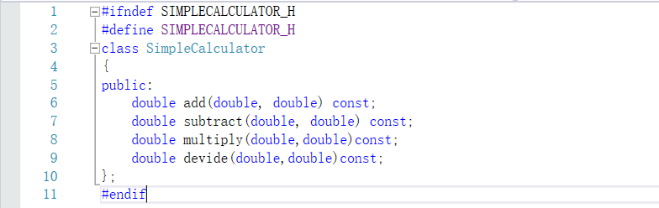

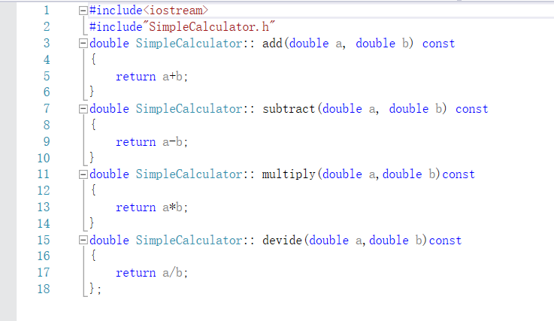

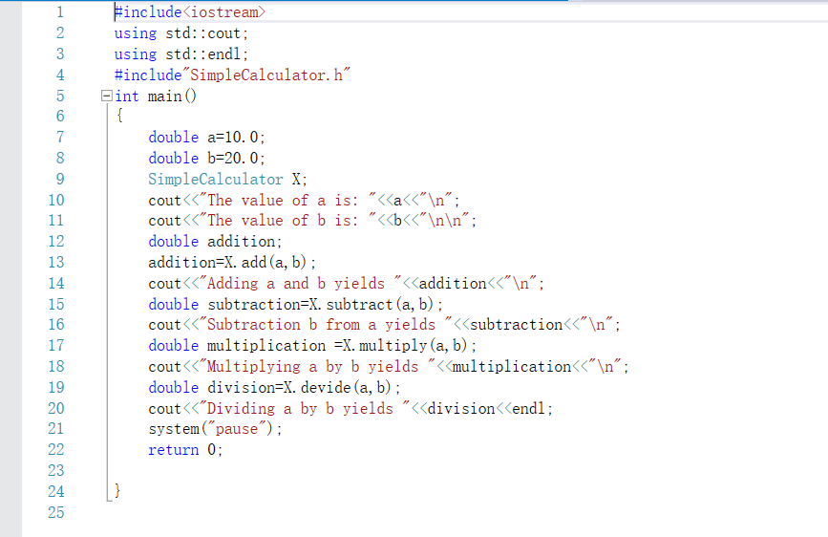

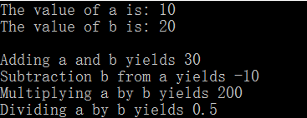

**Exp2:**

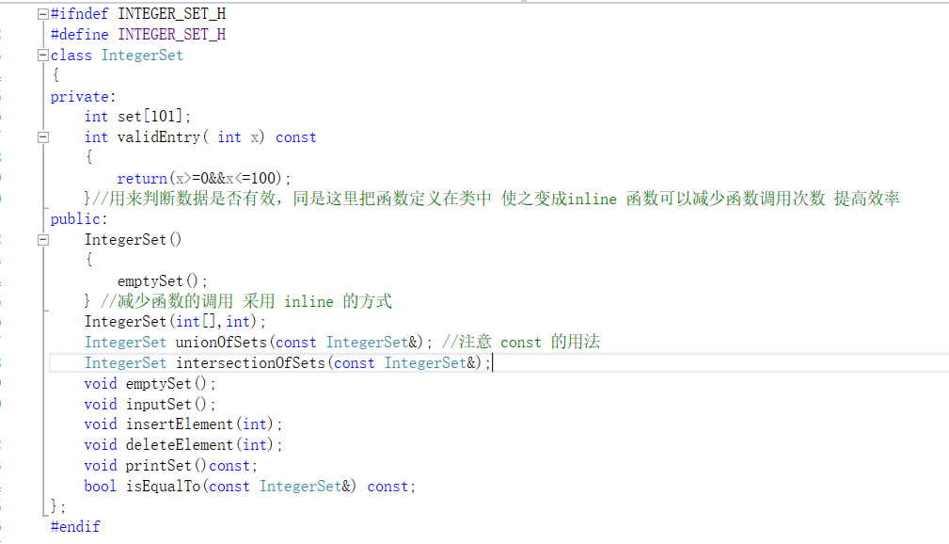

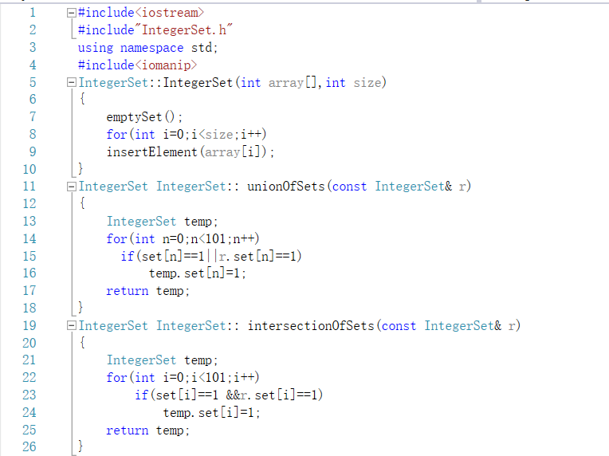

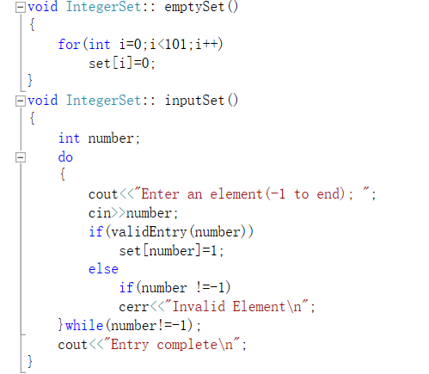

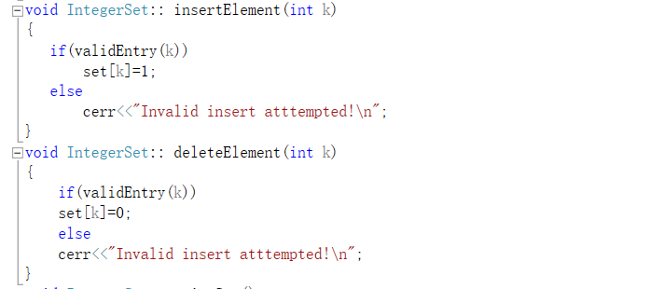

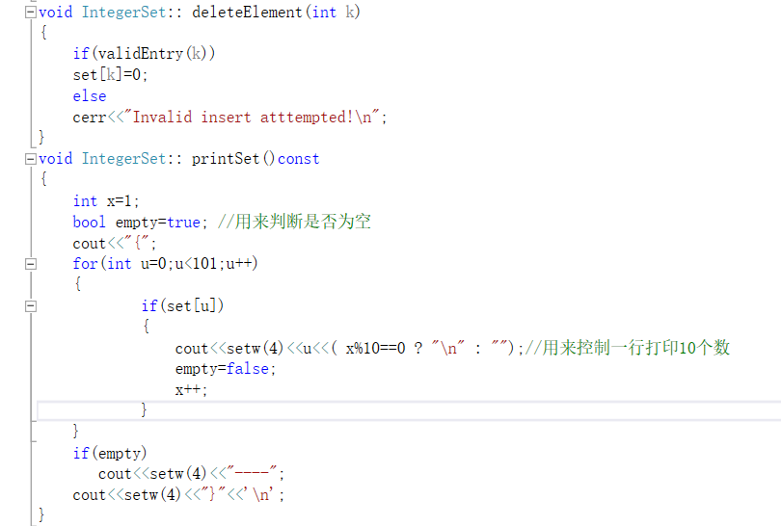

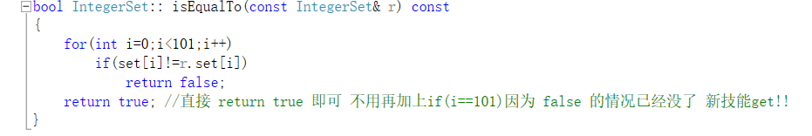

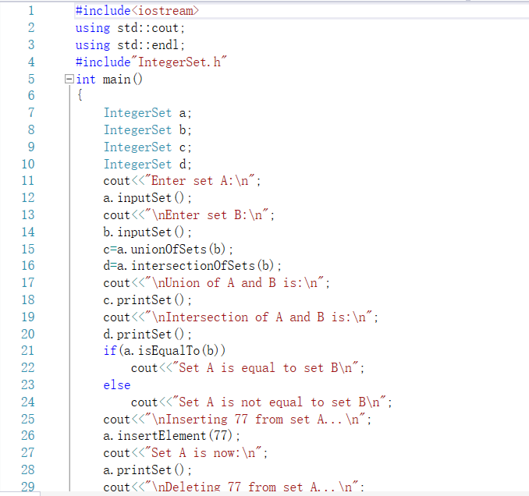

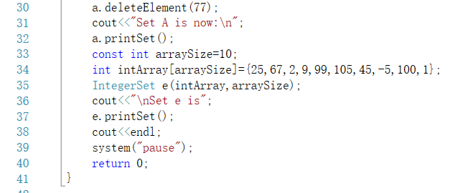

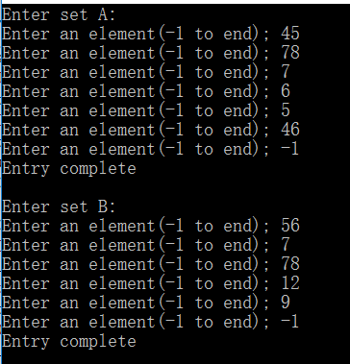

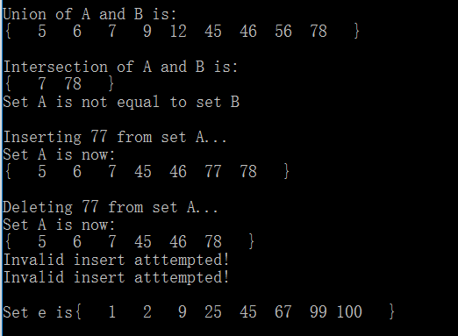

### 遇到的问题及解决过程

**Exp1:**nothing

**Exp2:**这里由于一开始在定义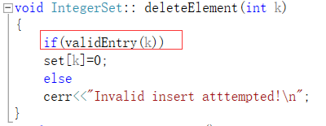这个函数的时候，忽略了对范围的判断，事实上delete函数和set函数一样都需要对数据的范围进行判断。否则在删除数据的时候就会出错，因为已经超出了数组的范围，所以在测试的时候，我delete超出100的数就会报错，加上了之后就解决了问题。

### 实验体会

**Exp1:**这里加深了对const限定词的应用，强化了 the least privilege 的原则。具体来说如果函数（普通函数，成员函数，运算符函数等等）的参数不需要改变值，那么最好加上const限定词来提高安全性，同时const限定词和指针，引用等结合是，既可以确保效率，也可以确保安全性。

**Exp2:**本实验有很多值得学习的地方。

1对数据范围的检查，也就是函数，这个函数用一个if语句进行判断，加上标准错误流就完成了对范围的检测

2 在类的定义中定义函数，那么这个函数就成为了inline 函数，本实验示范了inline函数的应用。



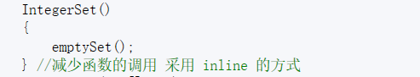

这两个函数都是inline函数，并且它们体积小，使用很频繁采用inline是最好的选择。同时这个类的构造函数都是用IntegerSet函数对数据进行初始化，并且将该函数设定成inline函数，既加强了程序的层次性，又保证了效率，是一个很值得学习的地方。概括一下就是：**用简单的inline函数直接对底层的数据初始化，然后高一层的函数在调用inline函数**

3同实验1，对const限定词的应用，以及加强了 the least privilege 原则

4用语句控制一行打印几个。

5